**DAILY ONLINE ACTIVITIES SUMMARY**

|  |  |  |  |  |  |  |  |  |
| --- | --- | --- | --- | --- | --- | --- | --- | --- |
| **Date:** | **28/06/2020** | | | | | **Name:** | **Sannidhi P** | |
| **Sem & Sec** | **8th B** | | | | | **USN:** | **4AL16CS084** | |
| **Online Test Summary** | | | | | | | | |
| **Subject** | | **-** | | | | | | |
| **Max. Marks** | | **-** | | **Score** | | | **-** | |
| **Certification Course Summary** | | | | | | | | |
| **Course** | **SOLOLEARN** | | | | | | | |
| **Certificate Provider** | | | **JAVASCRIPT Tutorial** | | **Duration** | | | **2hr** |
| **Coding Challenges** | | | | | | | | |
| **Problem Statement:**  **C program for Binary Search.** | | | | | | | | |
| **Status: Solved**  **Solution link: https://github.com/alvas-education-foundation/Sannidhi1** | | | | | | | | |
| **Uploaded the report in Github** | | | | | **Yes** | | | |
| **If yes Repository name** | | | | | **Sannidhi1** | | | |
| **Uploaded the report in slack** | | | | | **Yes** | | | |

Certification Course Details:

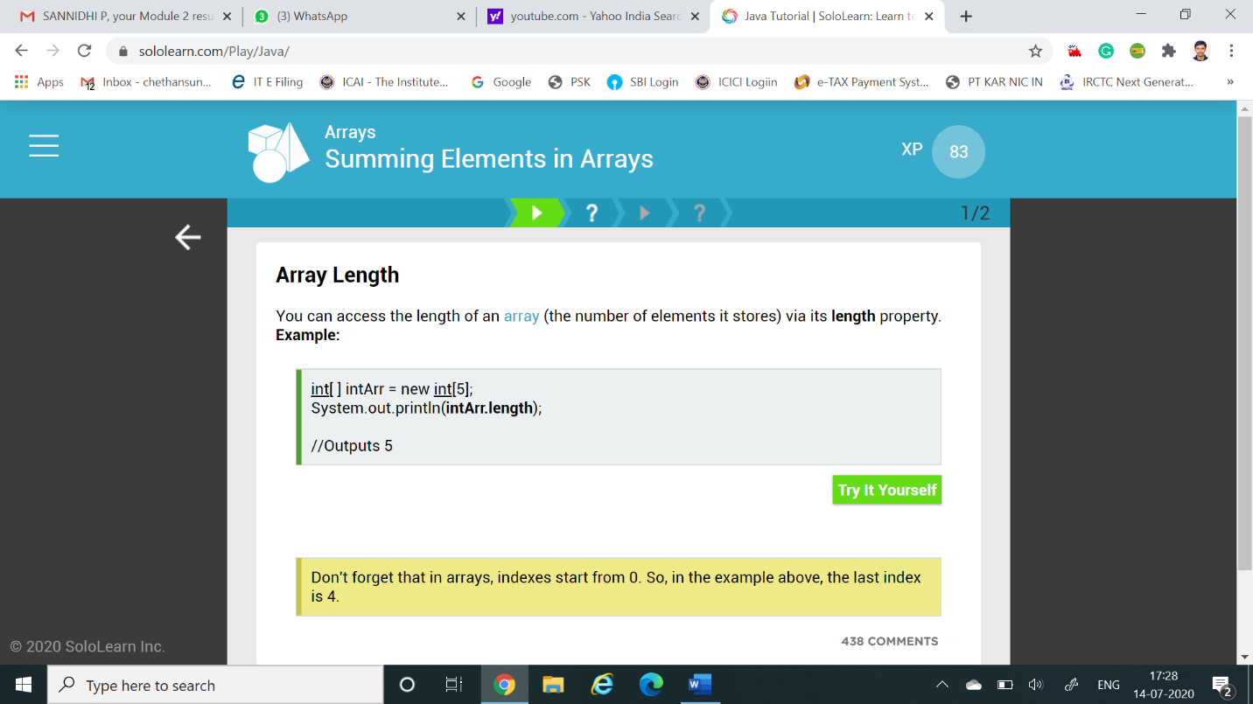

*Coding Challenges Details:*

#include <stdio.h>

int main()

{

int c, first, last, middle, n, search, array[100];

printf("Enter number of elements\n");

scanf("%d", &n);

printf("Enter %d integers\n", n);

for (c = 0; c < n; c++)

scanf("%d", &array[c]);

printf("Enter value to find\n");

scanf("%d", &search);

first = 0;

last = n - 1;

middle = (first+last)/2;

while (first <= last) {

if (array[middle] < search)

first = middle + 1;

else if (array[middle] == search) {

printf("%d found at location %d.\n", search, middle+1);

break;

}

else

last = middle - 1;

middle = (first + last)/2;

}

if (first > last)

printf("Not found! %d isn't present in the list.\n", search);

return 0;

}